**C PROGRAMMING PROBLEM-1(BASIC)**

1. **Write a c program to enter two number and their sum.**

**Code:**

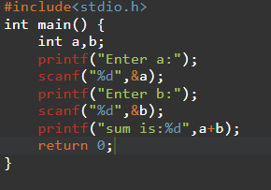

**OUTPUT:**

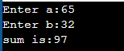

**2.Write a c program to enter two number and perform all arithmetic operations.**

**Code:**

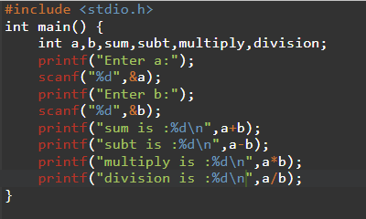

**Output:**

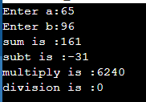

1. **Write a c program to enter length and breadth and calculate its perimeter and area.**

**Code:**

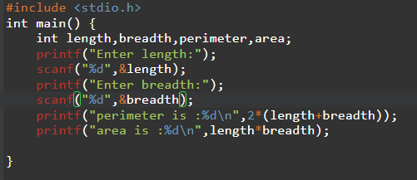

**OUTPUT:**

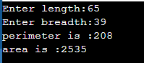

**4.write a c program to enter radius and find its diameter,circumference and area.**

**CODE:**

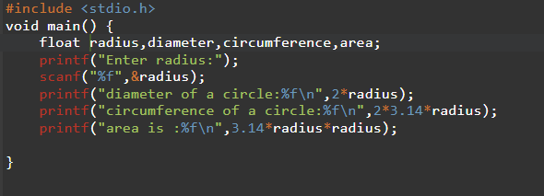

**OUTPUT:**

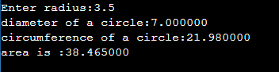

**5.Write a c program to enter value in Celsius and convert into fahrenheit.**

**CODE:**

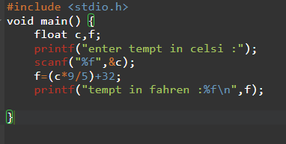

**Output:**



**6. Write a c program to enter value in Fahrenheit and convert into Celsius.**

**CODE:**

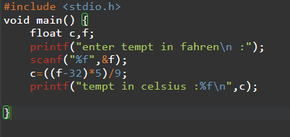

**OUTPUT:**

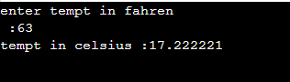

**7. Write a program to enter a length in centimetre and convert it into meter and Kilometer.**

**CODE:**

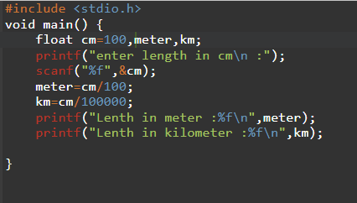

**OUTPUT:**

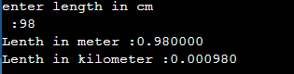

**8. Write a c program convert days into years,weeks and days.**

**CODE:**

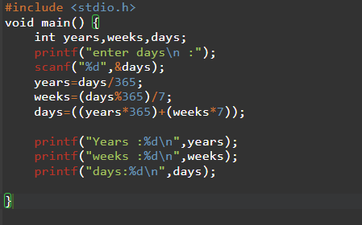

**OUTPUT:**

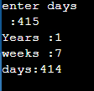

**9. Write a c program to find power of a any number a^b.**

**CODE:**

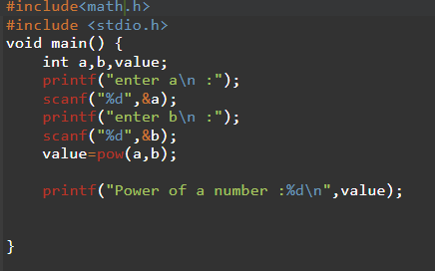

**OUTPUT:**

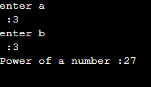

**10. Write a c program any number and calculate its squareroot.**

**CODE:**

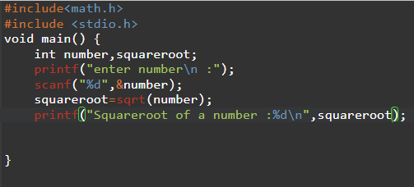

**OUTPUT:**

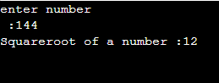

**11. Write a c program any two angles of a triangle and find its third angle.**

**CODE:**

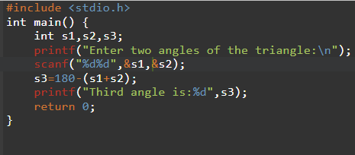

**OUTPUT:**

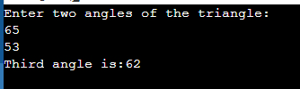

**12. Write a c program to enter base and height of a triangle and its area.**

**CODE:**

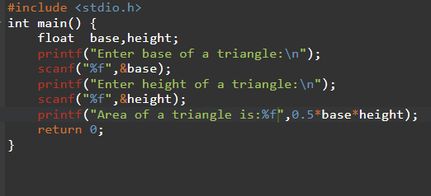

**OUTPUT:**

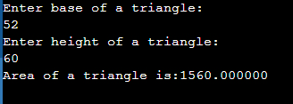

**13. Write a c program to calculate the area of an equilateral triangle.**

**CODE:**

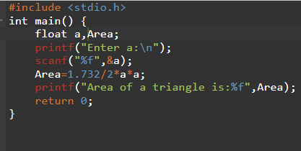

**OUTPUT:**

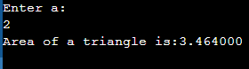

**14. Write a c program to enter marks of five subjects and calculate total,average and percentage.**

**CODE:**

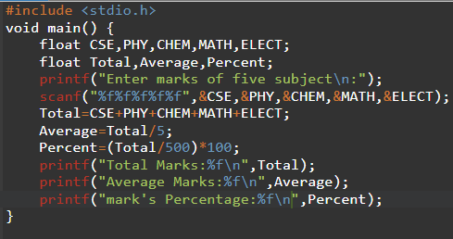

**OUTPUT:**

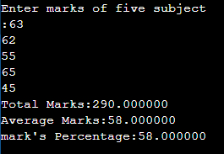

**15. Write a c program to enter p,n,r and calculate simple interest.**

**CODE:**

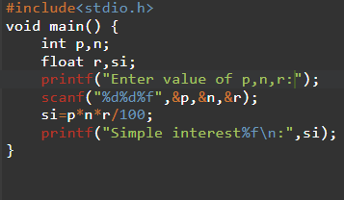

**OUTPUT:**

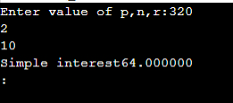

**16. Write a c program to enter p,n,r and calculate compound interest.**

**CODE:**

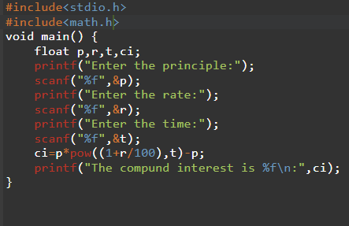

**OUTPUT:**

